RetinaGuard
DL analysis for detecting Diabetic Retinopathy
1. Introduction
- Project Title: RetinaGuard (A Deep Learning based fundus image analysis for diabetic retinopathy detection)
- Team Leader: Lakshmi Nihanth Vaidyam
- Team Members:
  - Dama Kiran Sai
  - Kalla Maikanta
  - Puneeth Abbu
  - Vidyala Gowtham Reddy
2. Project Overview
- Purpose:
The purpose of this project is to develop a deep learning-based web application that performs Binary classification of Diabetic Retinopathy from retinal fundus images.

Diabetic Retinopathy is a leading cause of blindness among diabetic patients. Early detection plays a crucial role in preventing severe vision loss. This project leverages Convolutional Neural Netwoks (CNNs) to automatically detect the presence of DR from medical images.

- Features:
  - Image-based DR detection using Deep Learning
  - Binary classification (DR/No DR)
  - Probability score output
  - Risk categorization (Low, Borderline, Moderate, High)
  - Flask-based REST API
  - Real-time prediction results
  - Privacy-focused (no image storage)
3. Architecture
- Frontend:
- HTML, CSS, JavaScript
- Animated, modern UI
- Drag-and-drop image upload
- Real-time result visualization
- Risk-level color indicators
- Responsive design (Desktop + Mobile)
- Backend:
- Python Flask application
- TensorFlow deep learning Model
- RESTful API for prediction
- In-memory image processing
- CORS enabled for frontend-backend communication
- Model:
- Model File: dr-binary_model.h5
- Framework: TensorFlow
- Input size: 224 x 224 RGB
- Preprocessing: Image resized and normalized (0-1 range)
4. Setup Instructions
- Prerequisites:
  - Python 3.10.x
  - Flask
  - Pandas, NumPy, Matplotlib
  - Joblib
  - Pillow
  - Kaggle API
- Installation:
  - Clone the repository.
  - Install dependencies: pip install -r requirements.txt
  - Ensure the model file is present
  - Run the Flask server: python flask_app.py
5. Folder Structure
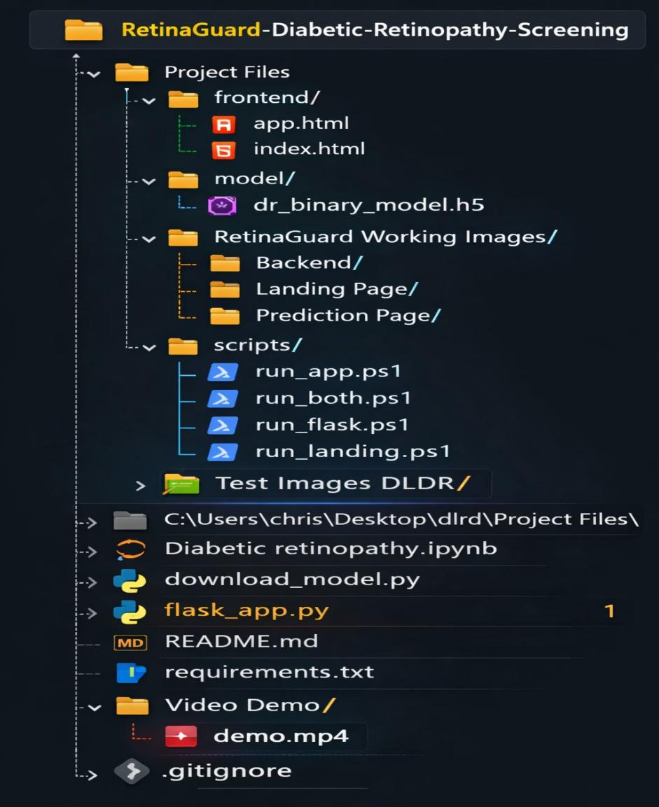

6. Running the Application
- Frontend: Rendered automatically by Flask Backend
- Backend: Start with”python flask_app.py”
- Access at http://127.0.0.1:5000/.
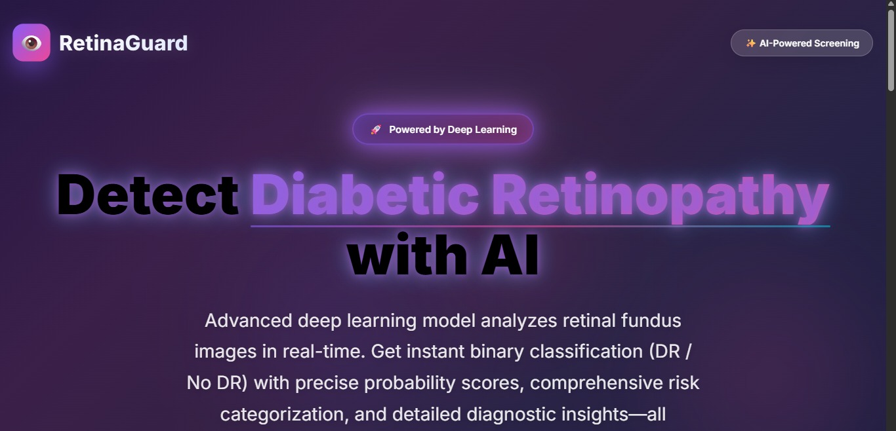

7. API Documentation
- Endpoint 1: ‘/’ (Landing Page)
  - Rendered Page: index.html
  - Method: GET
- Endpoint 2: ‘/app’
  - Rendered Page: app.html
  - Method: GET
  - Renders main application UI
- Endpoint 3: ‘/api/predict’
  - Rendered Page: predict.html
  - Method: POST
  - Content-Type: multipart/form-data
  - Renders predict page with model inference results and risk analysis details.
  - Sample output:
{ "success": true, "prediction": "DR Detected", "has_dr": true, "probability": 0.9112, "risk_category": "High Risk", "threshold": 0.4 }
  - Example Request:
curl -X POST \ -F "image=@retina_sample.jpg" \ http://localhost:5000/api/predict
- Endpoint 4: ‘/api/health’
  - Rendered Page: health.html
  - Method: GET
  - Returns server health status and confirms model loading.

8. Authentication
- Currently open access.
- Kaggle API required for dataset.
- Future scope:
- User login system
- secure API token based access
- RBAC for hospital/clinics

9. User Interface
- Landing Page with details about Diabetic Retinopathy, use cases.
- Dashboard with:
  - Modern animated background
  - Drag-and-frop image upload
  - Upload preview
  - Real-time prediction results
  - Risk evaluation with color codes
  - Animated probability meter
- Risk Categories:
  - Low Risk
  - Borderline Risk
  - Moderate Risk
  - High Risk

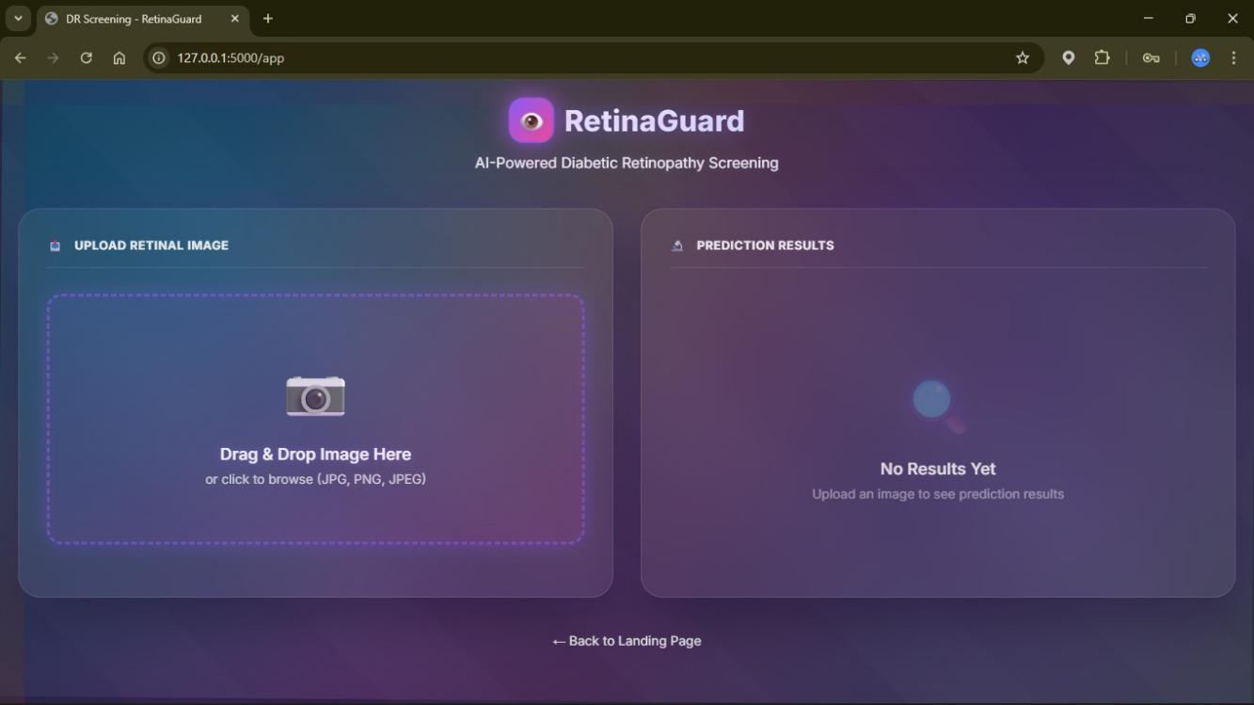

10. Testing
- Model Testing
- Validation accuracy evaluation
- Binary classification metrics
- Threshold testing
- API Testing
- POST request validation
- Image format validation
- Error handling for missing files
- Functional Testing
- Upload interface testing
- Risk category rendering
- Responsive design evaluation
11. Screenshots or Demo
- Confusion Matrix
- ROC curve
- Area Under Curve Score (AUC)
- Training vs Validation accuracy plot
12. Known Issues
- Model performance depends on training dataset quality
- Binary classification only
- Requires good quality retinal images
- No authentication implemented

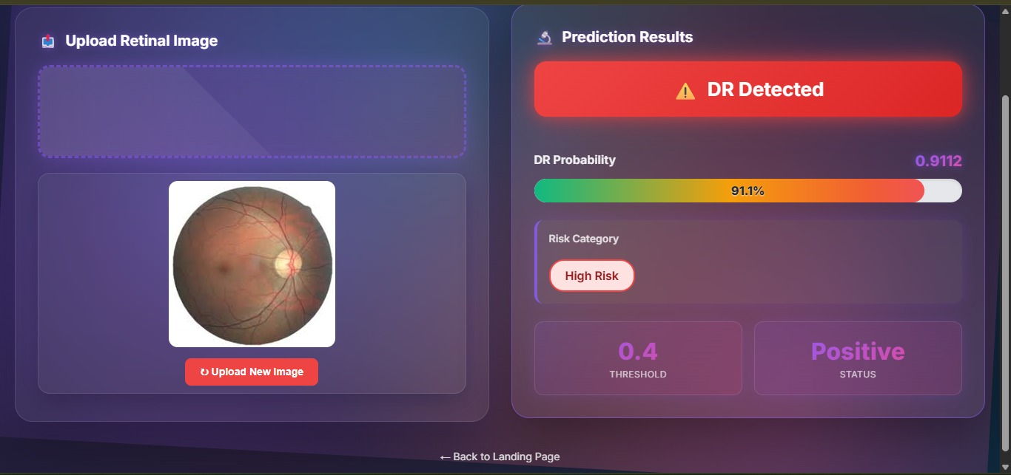
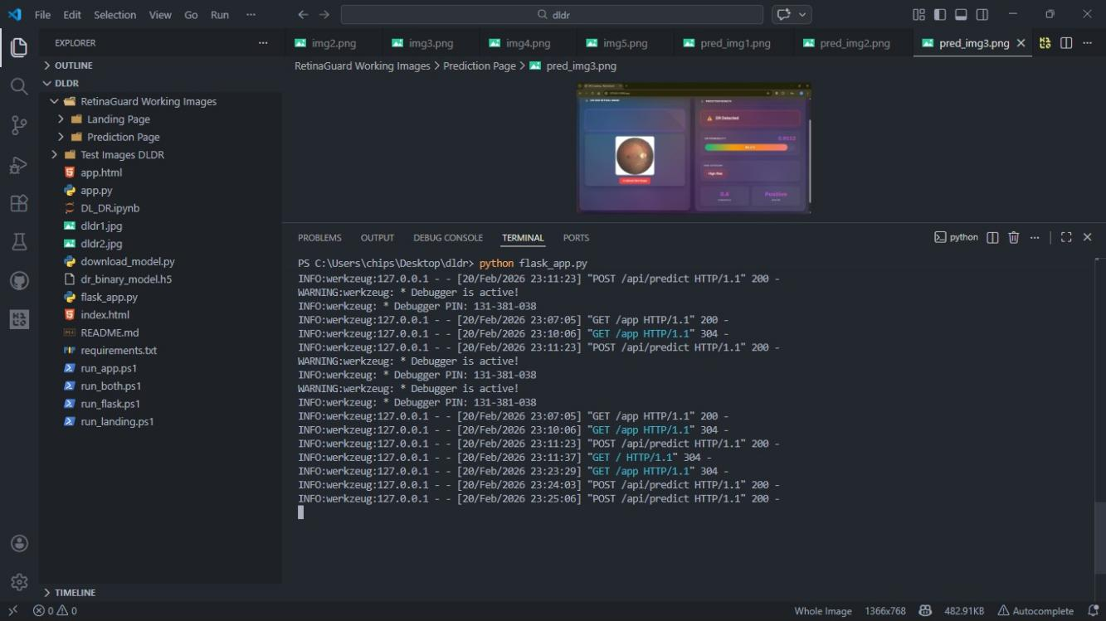

13. Future Enhancements
- Multi class DR severity classification
- Cloud Deployment (AWS/Azure/GCP)
- Mobile application integration
- Database integration for patient record storage

- Medical Disclaimer
This system is developed for research and educational purposes only.
It is not intended to replace medical diagnosis. Always onsult qualified healthcare professionals for medical advice and treatment decisions.

Conclusion
The Deep Learning-Based Diabetic Retinopathy Prediction System (RetinaGuard) successfully demonstrates the practical application of artificial intelligence in medical image analysis. By leveraging a Convolutional Neural Network (CNN) model trained on retinal fundus images, the system performs reliable binary classification to detect the presence of Diabetic Retinopathy. The integration of probability scoring and risk categorization enhances interpretability, allowing users to understand not just the prediction, but the confidence level behind it.
The project effectively combines machine learning and full-stack development through a TensorFlow-based model and a Flask-powered REST API. The responsive web interface ensures that users can easily upload retinal images and receive real-time predictions. Additionally, the system is designed with privacy in mind, as all image processing occurs in memory without storing patient data. This makes the solution suitable for research environments and potential clinical integration.
From a technical perspective, the model evaluation using metrics such as confusion matrix, ROC curve, accuracy, and loss curves confirms the robustness and reliability of the classification system. The architecture is modular and scalable, allowing future enhancements such as multi-class DR severity grading, Grad-CAM visualization for explainability, and cloud deployment for wider accessibility.
Overall, this project highlights the transformative potential of deep learning in healthcare diagnostics. RetinaGuard serves as a foundational step toward intelligent, accessible, and scalable AI-driven screening systems that can assist healthcare professionals in early detection and timely intervention, ultimately contributing to the prevention of vision loss caused by Diabetic Retinopathy.

